

System Provisioning and Configuration Management Lab

**Submitted by:  
Aryan Karnwal  
500101796  
R2142220239  
Devops B2(NH)**



**EXPERIMENT 3**

# Lab Exercise: Creating Static Host Inventory

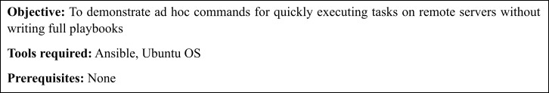

**Steps to be followed:**

1. Generate SSH key pair on the main node
2. Copy the SSH key on the other two nodes
3. Update the host file with the host IP address
4. Establish connectivity between specified hosts and the Ansible server
5. Gather System Information Using Ad-Hoc Commands

# Step 1: Establish connectivity between specified hosts and the Ansible server

* 1. Run the following command to verify connectivity to all servers listed under the

**webservers** group in your Ansible hosts file: **ansible -m ping dbservers**

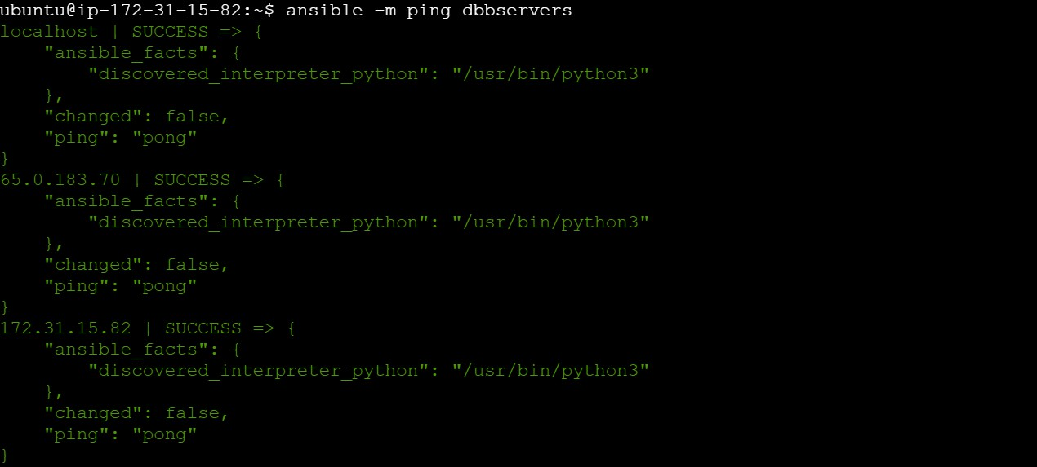

* 1. Use the following command to check the number of hosts in the host file:

# ansible all --list-hosts

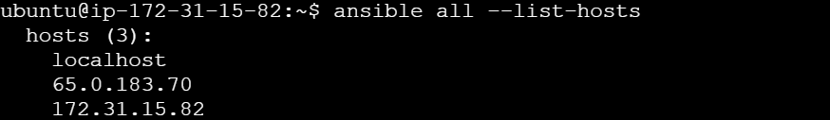

**Step 2: Gather System Information Using Ad Hoc Commands**

* 1. 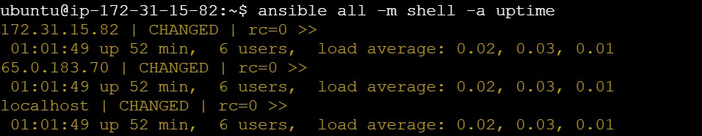Run the following command to obtain the uptime from all managed hosts using an ad hoc command: **ansible all -m shell -a uptime**
  2. Similarly, execute the below command to obtain detailed information about memory usage on all hosts: **ansible all -m shell -a "free -m"**

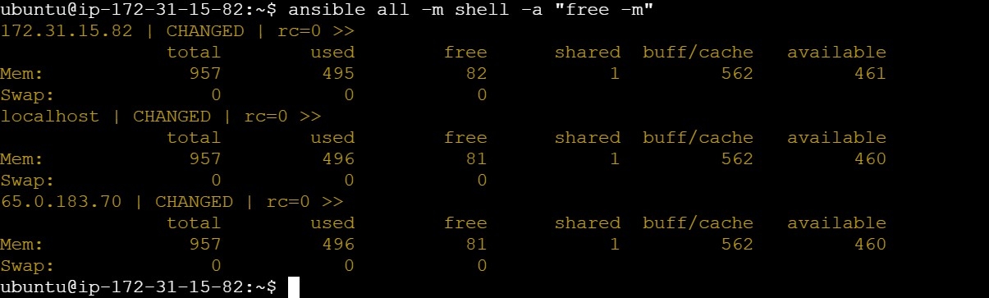

You will see that Ansible logs in to each machine in turn and runs the uptime command, returning the current uptime output.

By following these steps, you have successfully demonstrated how to use ad hoc commands for quickly executing tasks on remote servers without the need for full playbooks.